Create two tables in your database: 'restaurants' (id, name, city) and 'dishes' (id, restaurant_id, dish_name, price). Insert at least 3 restaurants and 2-3 dishes for each restaurant.
Tables:
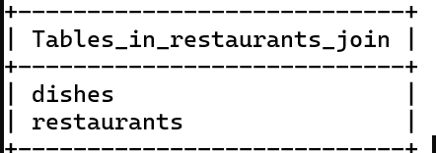

Insert at least 3 restaurants and 2-3 dishes for each restaurant.
Table 1 | Table 2
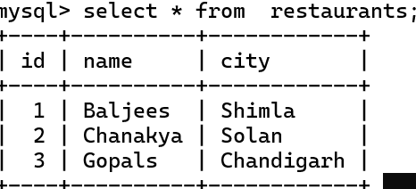 | 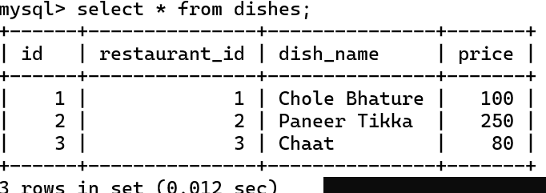

Write an SQL INNER JOIN query to display each dish along with its restaurant name and city, similar to how Zomato shows dish details with the restaurant info.
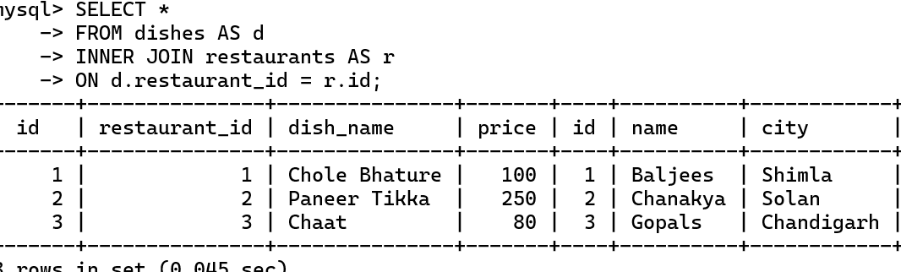

Write an SQL LEFT JOIN query to list all restaurants and their dishes, showing restaurants even if they currently have no dishes on the menu.<br><br><em><strong>Hint:</strong> Use LEFT JOIN so restaurants without dishes still appear in the results with NULL for dish columns.</em>
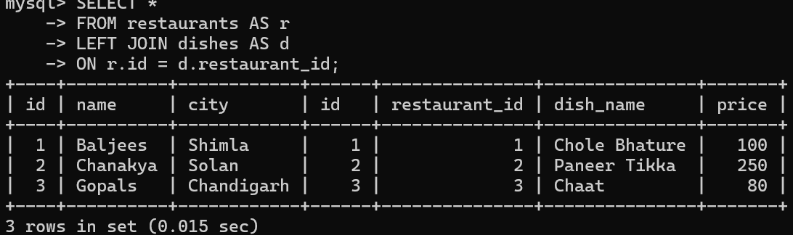

Write an SQL RIGHT JOIN query to display all dishes and their restaurant names, including any dishes that might not be linked to a restaurant (simulate a data error where a dish has a restaurant_id that doesn't match any restaurant).

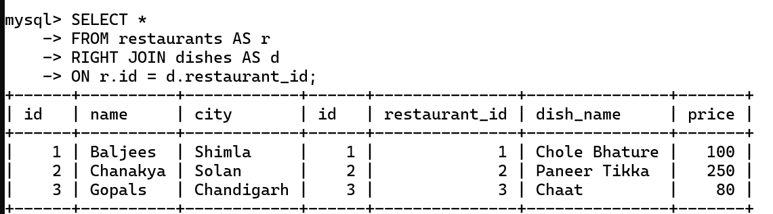

Given this scenario: You want to show a list of all playlists and the songs inside them, like Spotify. Explain which JOIN type (INNER, LEFT, or RIGHT) you would use to show all playlists, even if some are empty, and write the SQL query for it.
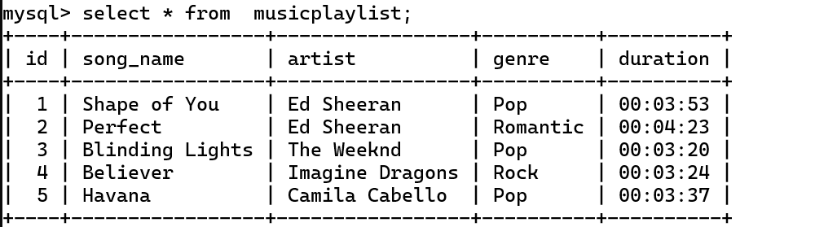
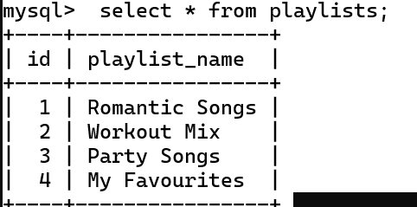

I would use Left Join

O/P:



